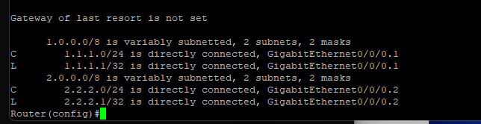

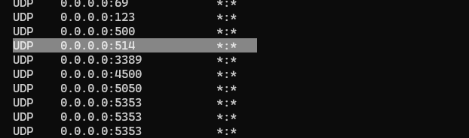

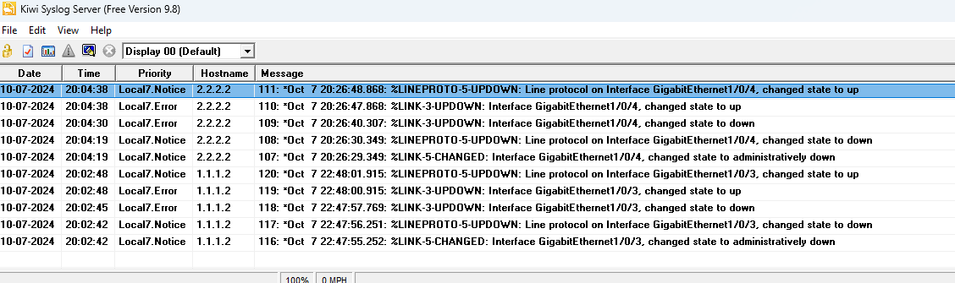
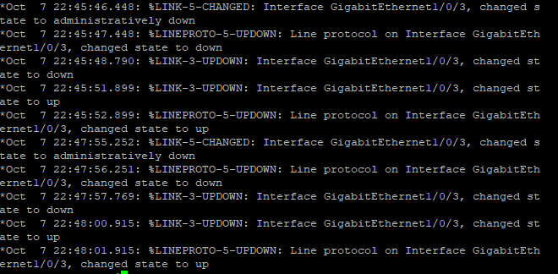

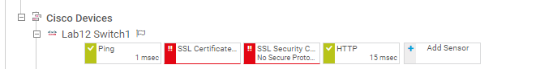
Snmp-server source-interface informs gigabitEthernet 0/0/0.2
Snmp-server source-interface traps gigabitEthernet 0/0/0.2
